GROUP ASSIGNMENT

**TECHNOLOGY PARK MALAYSIA**

**AICT005-4-1-DAS**

DATABASE SYSTEMS

UCDF2304ICT

HAND OUT DATE: 18th October 2023

HAND IN DATE: 5th December 2023

WEIGHTAGE: 50%

MODULE LECTURER: MUHAMMAH HUZAIFAH BIN ISMAIL

INSTRUCTION:

1. **Submit your assignment in the APU Moodle.**
2. **Students are advised to underpin their answers with the use of references (cited using the APA System of Referencing).**
3. **Late submission will be awarded zero (0) unless Extenuating Circumstances (EC) are upheld.**
4. **Cases of plagiarism will be penalized.**

|  |  |
| --- | --- |
| **Student Name** | **TP Number** |
| Alice Lim Jia Chee | TP074521 |
| Bryan Wong Junyi | TP074948 |
| Natalie Chew Jing Ling | TP073085 |
| Ng Jun Yuan | TP067314 |

**Table of Contents**

**1.0 Database Schema**

**1.1 Entity Relationship Diagram……………………………………… 3**

**1.2 Database Diagram………………...……………………………….. 4**

**2.0 SQL-Data Definition Language (DDL)**

**2.1 Publisher Table………………...………….……………………….. 5**

**2.2 Manager Table………………...……………………...……………..6**

**2.3 Member Table………………...…………………...……………….. 7**

**2.4 Book Table………………...………………………….…………….. 8**

**2.5 Feedback Table………………...……………….………………….. 9**

**2.6 Publisher Order Table………………...………...……..…………..10**

**2.7 Watch Table………………...…...…………………..…………….. 11**

**2.8 Shopping Cart Table……….………...………..………………….. 12**

**2.9 Member Order Table………………...………..………………….. 13**

**3.0 SQL-Data Manipulation Language (DML)** **.…………..... 14-23**

**Workload Matrix**

**1.0 Database Schema**

**1.1 Entity Relationship Diagram**

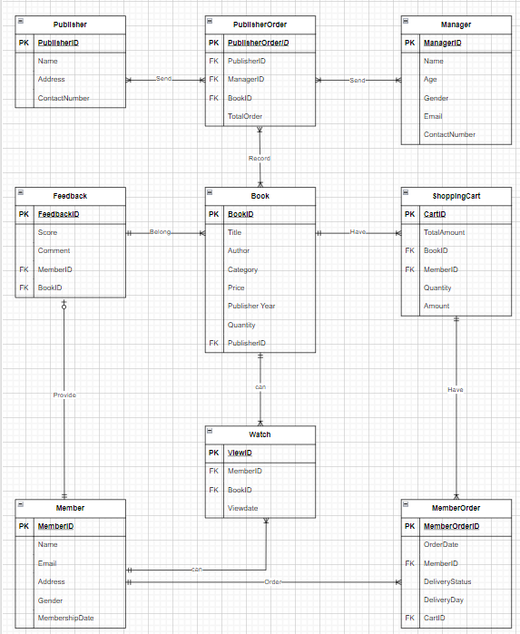

Figure 1.1: Entity Relationship Diagram (ERD)

**1.2 Database Diagram**

Figure 1.2: Database Diagram

**2.0 SQL-Data Definition Language (DDL)**

**2.1 Publisher Table**

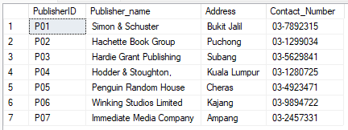

Figure 2.1.1 Publisher Table

Figure 2.1.2 CREATE TABLE Statement - Publisher Table

Figure 2.1.3 INSERT DATA Statement - Publisher Table

**2.2 Manager Table**

Figure 2.2.1 Manager Table

Figure 2.2.2 CREATE TABLE Statement - Manager Table

Figure 2.2.3 INSERT DATA Statement - Manager Table

**2.3 Member Table**

Figure 2.3.1 Member Table

Figure 2.3.2 CREATE TABLE Statement - Member Table

Figure 2.3.3 INSERT DATA Statement - Member Table

**2.4 Book Table**

Figure 2.4.1 Book Table

Figure 2.4.2 CREATE TABLE Statement - Book Table

Figure 2.4.3 INSERT DATA Statement - Book Table

**2.5 Feedback Table**

Figure 2.5.1 Feedback Table

Figure 2.5.2 CREATE TABLE Statement - Feedback Table

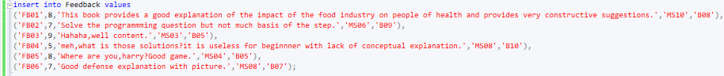

Figure 2.5.3 INSERT DATA Statement - Feedback Table

**2.6 Publisher Order Table**

Figure 2.6.1 Publisher Order Table

Figure 2.6.2 CREATE TABLE Statement - Publisher Order Table

Figure 2.6.3 INSERT DATA Statement - Publisher Order Table

**2.7 Watch Table**

Figure 2.7.1 Watch Table

Figure 2.7.2 CREATE TABLE Statement - Watch Table

Figure 2.7.3 INSERT DATA Statement - Watch Table

**2.8 Shopping Cart Table**

Figure 2.8.1 Shopping Cart Table

Figure 2.8.2 CREATE TABLE Statement - Shopping Cart Table

Figure 2.8.3 INSERT DATA Statement - Shopping Cart Table

**2.9 Member Order Table**

Figure 2.9.1 Member Order Table

Figure 2.9.2 CREATE TABLE Statement - Member Order Table

Figure 2.9.3 INSERT DATA Statement - Member Order Table

**3.0 SQL-Data Manipulation Language (DML)**

3.1) List all the book(s) and sort from highest to lowest of rating. Show book id, book name, publisher, and the rating.

Figure 3.1.1 SQL Query Statements for Question 1

Figure 3.1.2 Results from Executed Query Statements for Question 1

3.2) Find the total number of feedback per member. Show member id, member name, and total number of feedback per member.

Figure 3.2.1 SQL Query Statements for Question 2

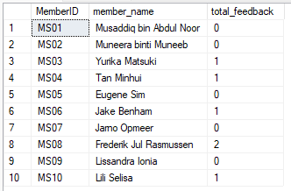

Figure 3.2.2 Results from Executed Query Statements for Question 2

3.3) Find the total number of books published by each publisher and sort by total number of books in ascending order. Show publisher id, publisher name, and total number of book published.

Figure 3.3.1 SQL Query Statements for Question 3

Figure 3.3.2 Results from Executed Query Statements for Question 3

3.4) Find the total number of books ordered by store manager from each publisher.

Figure 3.4.1 SQL Query Statements for Question 4

Figure 3.4.2 Results from Executed Query Statements for Question 4

3.5) From the book table, list the books where quantity is more than the average quantity of all books

Figure 3.5.1 SQL Query Statements for Question 5

Figure 3.5.2 Results from Executed Query Statements for Question 5

3.6) List the top 3 bestselling book(s).

Figure 3.6.1 SQL Query Statements for Question 6

Figure 3.6.2 Results from Executed Query Statements for Question 6

3.7) List the top 5 genre bestselling book(s).

Figure 3.7.1 SQL Query Statements for Question 7

Figure 3.7.2 Results from Executed Query Statements for Question 7

3.8) Show the total members based on gender who are registered as members in APU EBookstore.

Figure 3.8.1 SQL Query Statements for Question 8

Figure 3.8.2 Results from Executed Query Statements for Question 8

3.9) A list of purchased books that have not been delivered to members. The list should show member identification number, address, contact number, book serial number, book title, quantity, date and status of delivery.

Figure 3.9.1 SQL Query Statements for Question 9



Figure 3.9.2 Results from Executed Query Statements for Question 9

3.10) Show the members who made 2 or more orders.

Figure 3.10.1 SQL Query Statements for Question 10



Figure 3.10.2 Results from Executed Query Statements for Question 10

**AICT005-4-1 Database Systems – Workload Matrix (Part 1)**

|  |  |  |  |  |  |  |
| --- | --- | --- | --- | --- | --- | --- |
| **Part** | **Component** | **Student 1 Name: Alice Lim Jia Chee** | **Student 2 Name: Bryan Wong Junyi** | **Student 3 Name: Natalie chew Jing Ling** | **Student 4 Name: Ng Jun Yuan** | **Total** |
| **1** | 1. Database and Database Management System | **25%** | **25%** | **25%** | **25%** | **100%** |
| **1** | 1. Business Rules & Normalization | **25%** | **25%** | **25%** | **25%** | **100%** |
| **1** | 1. Entity Relationship Diagram | **25%** | **25%** | **25%** | **25%** | **100%** |

**\*Ignore ‘student 4’ column if there are only 3 members**

**\*Total % of contribution of all member must sum up to 100%**

**AICT005-4-1 Database Systems – Workload Matrix (Part 2)**

|  |  |  |  |  |  |  |
| --- | --- | --- | --- | --- | --- | --- |
| **Part** | **Component** | **Student 1 Name:**  **Alice Lim Jia Chee** | **Student 2 Name:**  **Bryan Wong Junyi** | **Student 3 Name:**  **Natalie Chew Jing Ling** | **Student 4 Name:**  **Ng Jun Yuan** | **Total** |
| **2** | 1. Database Schema | **25%** | **25%** | **25%** | **25%** | **100%** |
| **2** | 1. SQL-Data Definition Language (DDL) | **25%** | **25%** | **25%** | **25%** | **100%** |
| **2** | 1. SQL-Data Manipulation Language (DML) | **25%** | **25%** | **25%** | **25%** | **100%** |

*Individual component is omitted because marks will be awarded separately

*Ignore student 4 column if there are only 3 members

*Total % of contribution of all members must sum up to 100%